Experiment 3 — Correlation Analysis (Pearson Coefficient)

Name : Prem Vijay Hanchate
Roll no : 68 Class : TE/IT

Aim
To perform data wrangling and preprocessing operations on the Aadhar Enrollment dataset using the Pandas library, including handling missing values, removing duplicates, replacing values, applying custom functions, sorting, pivoting, and grouping, in order to prepare the dataset for further analysis.

Theory
1. Pandas and DataFrames: Pandas is an open-source Python library built on top of NumPy, designed for data manipulation and analysis. Its primary data structure, the DataFrame, is a two-dimensional, tabular, labeled structure that can hold columns of different data types. It is the most widely used tool for structured data wrangling in Python.
2. Data Inspection: Before any manipulation, it is essential to understand the dataset. Key inspection functions include:
- head() / tail() — View first and last N rows.
- info() — Column names, data types, and non-null counts.
- describe() — Summary statistics for numeric columns.
- shape — Dimensions (rows, columns).
- columns — List of all column names.
3. Missing Value Treatment: Real-world datasets often contain null or NaN values. The isnull().sum() function identifies the count of missing values per column. Treatment strategies include:
- Numeric columns — Filling with the column mean using fillna(mean) preserves the overall distribution.
- Categorical/text columns — Filling with a placeholder such as "Not Provided" avoids data loss while flagging incomplete records.
In this dataset, missing values were found in State (1), district (5), pincode (14), age_0_5 (5), age_5_17 (5), and age_18_greater (4), all of which were handled by filling with the mean or a placeholder.
4. Duplicate Detection and Removal: Duplicate rows can skew analysis results. The duplicated() function identifies repeated rows, and drop_duplicates() removes them. In this experiment, a test set of 101 rows (with 2 intentional duplicates added) was reduced back to 99 unique records after applying drop_duplicates().
5. Value Replacement: The replace() function is used to substitute existing values with new ones. This is useful for standardizing inconsistent labels, correcting data entry errors, or recoding categorical variables.
6. Derived Columns and Custom Functions: New columns can be engineered from existing ones using:
- apply() — Applies a custom function row-wise or column-wise.
- Direct assignment — Creating new columns using arithmetic or string operations.
In this experiment, two derived columns were created — a category label based on pincode range, and a short code extracted from the State name — demonstrating how domain knowledge can be embedded into the dataset.
7. Sorting: The sort_values() function arranges rows based on one or more columns in ascending or descending order. Sorting is useful for ranking records, identifying top/bottom entries, and preparing data for display.
8. Pivot Table: A pivot table reorganizes data by aggregating values across two dimensions. Pandas pivot_table() function works similarly to Excel pivot tables, allowing grouping by rows and columns with an aggregate function (sum, mean, count). In this experiment, enrollment data was pivoted by Date and State.
9. Group-By Aggregation: The groupby() function splits the dataset into groups based on a column, applies an aggregation function (sum, mean, count), and combines the results. It is one of the most powerful tools in Pandas for deriving insights at a categorical level. Here, data was grouped by both Date and State to compute aggregate enrollment summaries.
10. File I/O Operations: Pandas supports reading and writing multiple file formats:
- read_excel() / to_excel() — For .xlsx files.
- read_csv() / to_csv() — For .csv files.

Execution
The following operations were performed step-by-step on the Aadhar Enrollment dataset:
Step 1 — Load Data: The Excel file Sample_Aadhar_Enrollment_Dataset.xlsx was loaded into a Pandas DataFrame using read_excel(). The dataset contained 99 rows and 7 columns: Date, State, district, pincode, age_0_5, age_5_17, and age_18_greater.
Step 2 — Inspect Data: Basic inspection was performed using head(), tail(), info(), describe(), shape, and columns to understand the structure, data types, and statistical properties of the dataset.
Step 3 — Detect Missing Values: isnull().sum() was used to identify missing values. The following nulls were found before cleaning:
Step 4 — Handle Missing Values: Numeric columns were filled with their respective column means using fillna(). Text columns (State, district) were filled with "Not Provided". After treatment, all missing value counts became 0.
Step 5 — Duplicate Handling: Two duplicate rows were intentionally added to create a 101-row test set. drop_duplicates() was applied, successfully reducing the dataset back to 99 unique records.
Step 6 — Value Replacement: replace() was used to substitute specific values in the dataset, demonstrating how inconsistent entries can be standardized programmatically.
Step 7 — Derived Columns: A pincode_category column was created to classify pincodes into ranges. A state_code column was derived by extracting a short identifier from the State name using apply() with a custom function.
Step 8 — Sorting: The dataset was sorted by enrollment columns to rank records from highest to lowest enrollment counts.
Step 9 — Pivot Table: A pivot table was created using Date and State as axes, with enrollment columns as values, summarizing enrollment totals across time and geography.
Step 10 — Group-By Summaries: groupby() was applied on Date and State separately to generate aggregate enrollment summaries per group.
Step 11 — File Export: The cleaned dataset was saved as Aadhar_Enrollment_Data.csv using to_csv() and as Aadhar_Enrollment_Output.xlsx using to_excel().

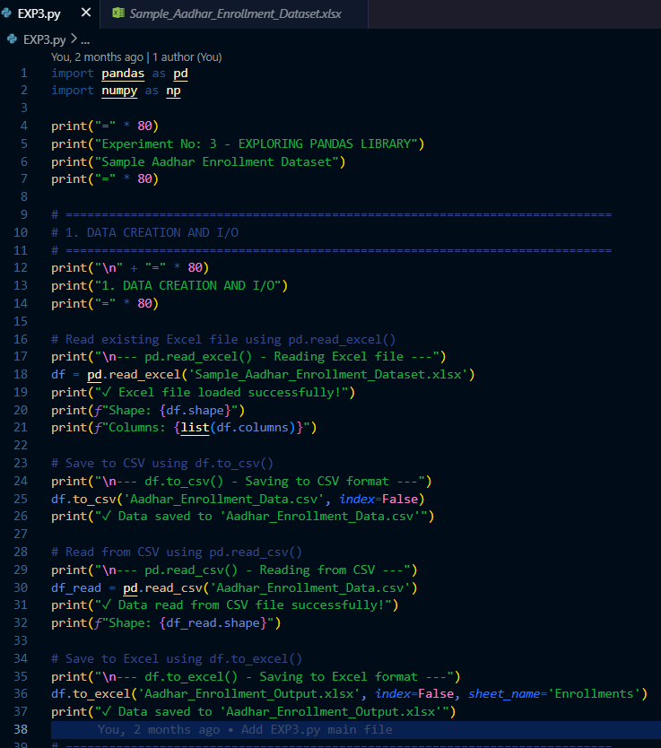
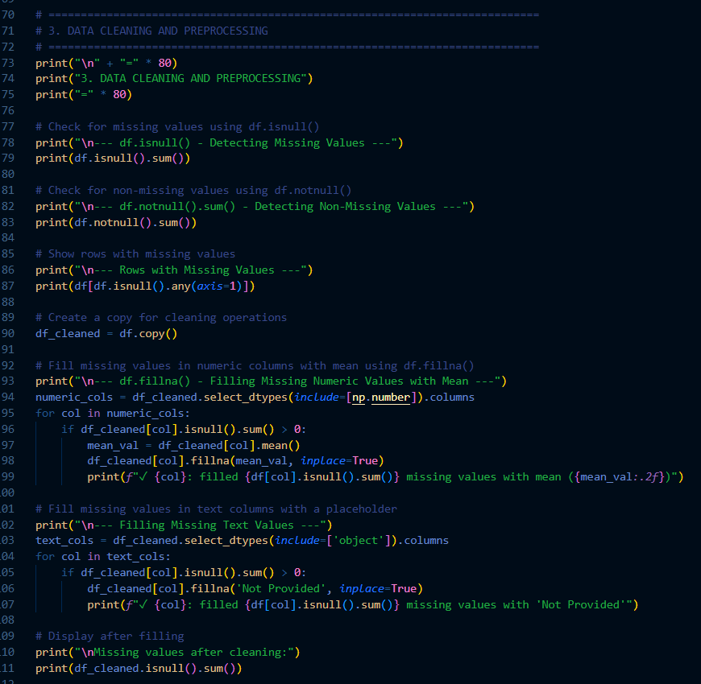
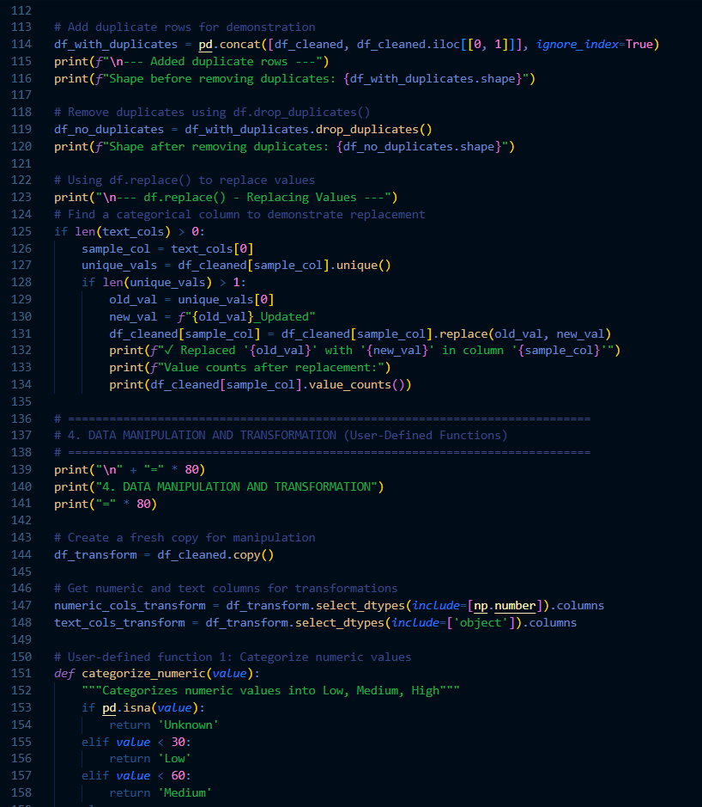
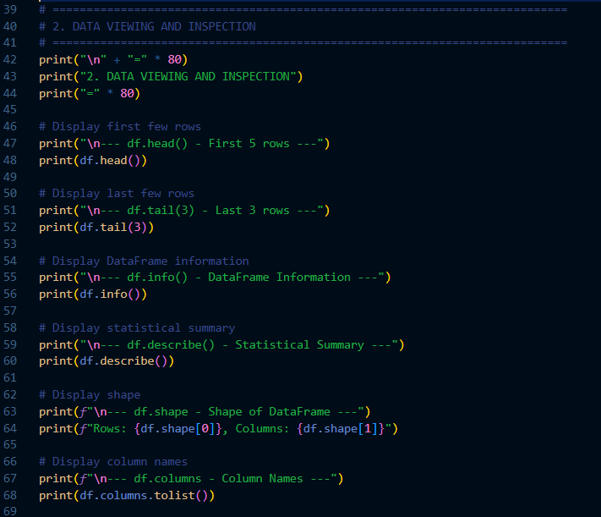
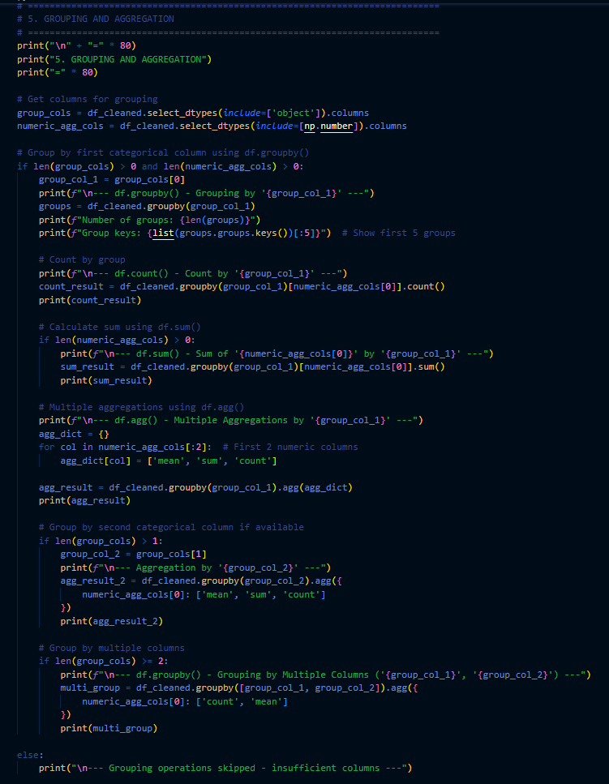
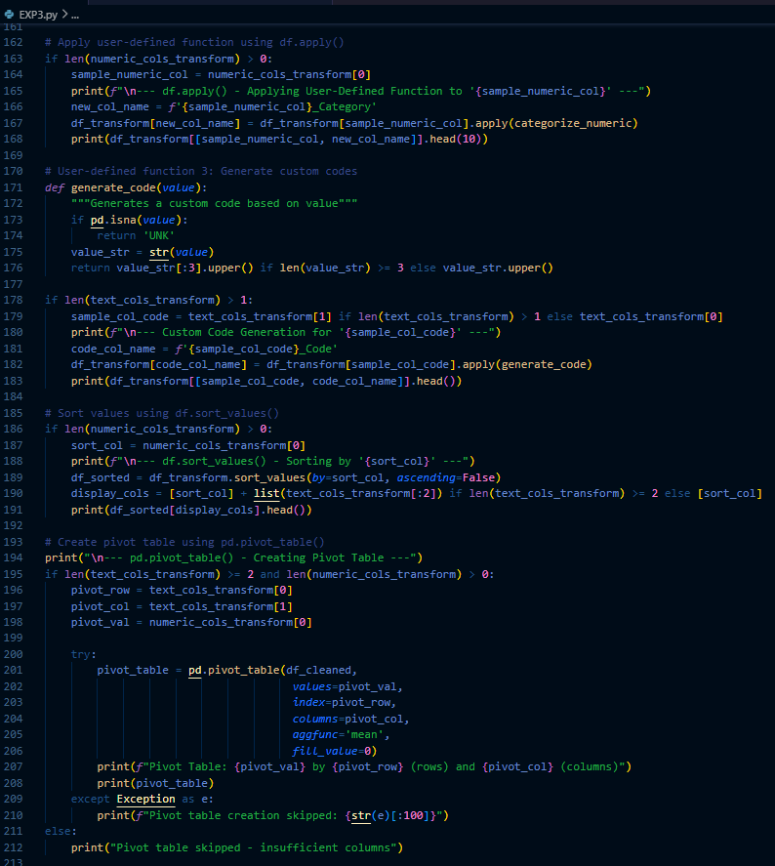

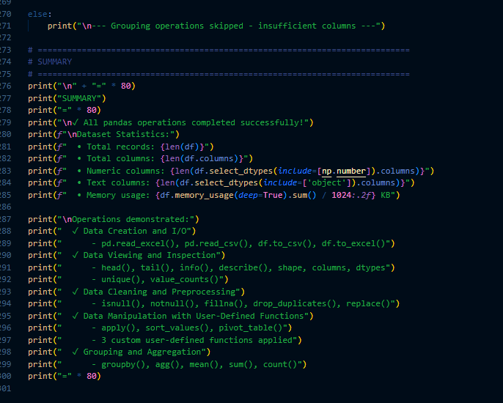

Output
1. Data Creation and I/O
- Read from Excel file
- Saved to CSV and Excel formats
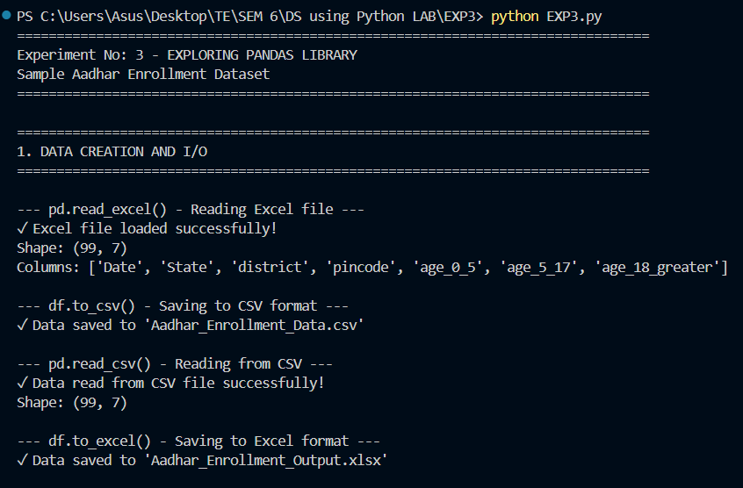
2. Data Viewing and Inspection
- Displayed first/last rows, info, statistics
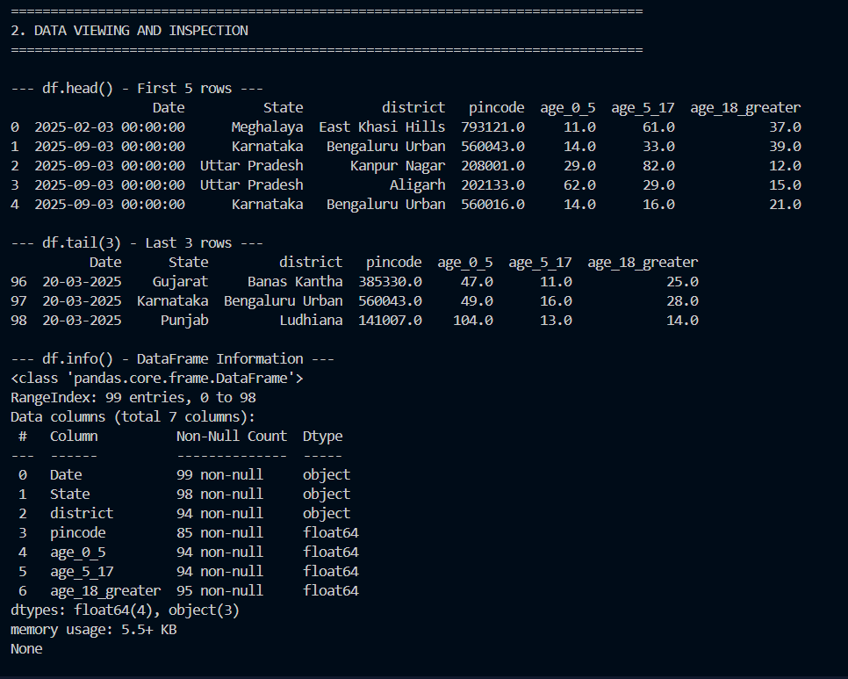
- Showed unique values and distributions
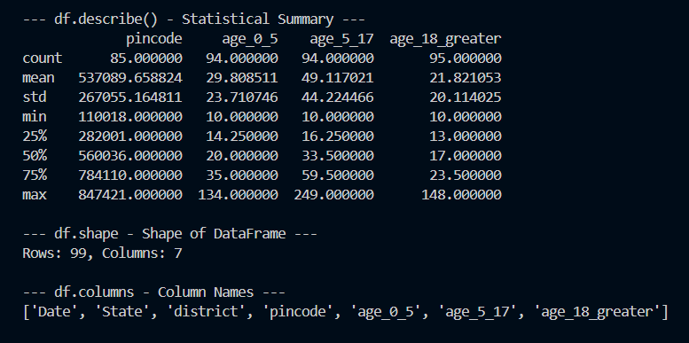

3. Data Cleaning and Preprocessing
- Detected 27 rows with missing values
- Filled missing numeric values with mean
- Filled missing text with "Not Provided"
- Removed duplicate rows

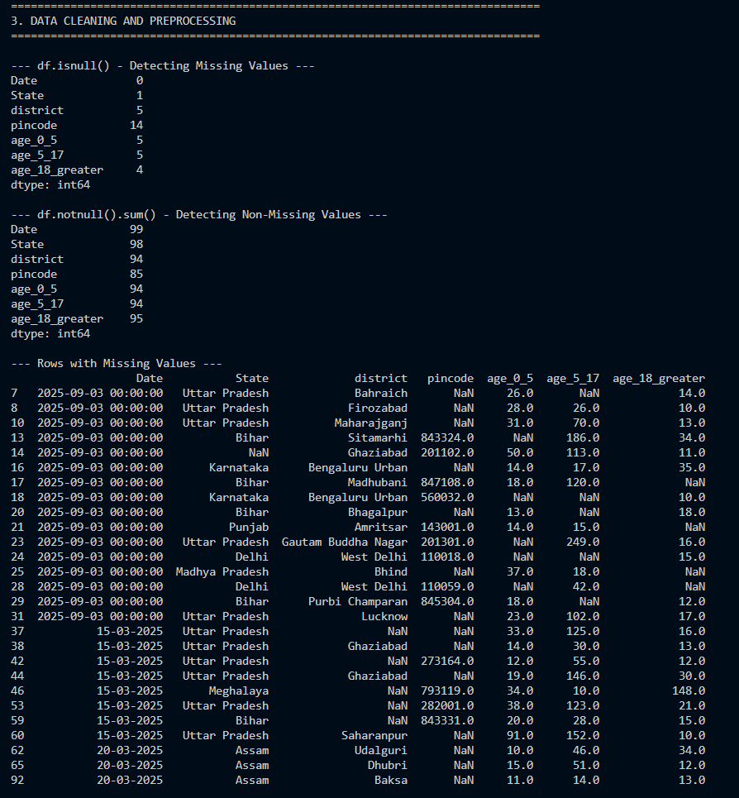
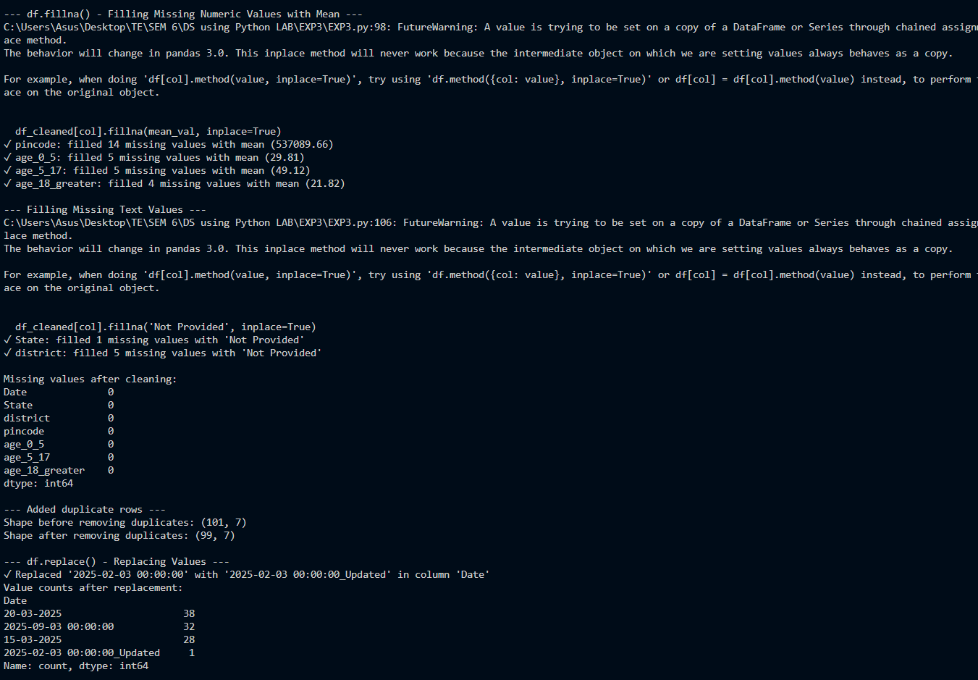
4. Data Manipulation (3 User-Defined Functions)
- categorize_numeric() - Categorized pincode into Low/Medium/High
- generate_code() - Generated state codes (MEG, KAR, UTT, etc.)

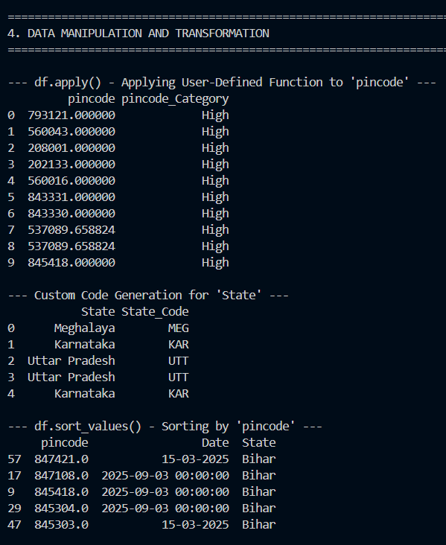
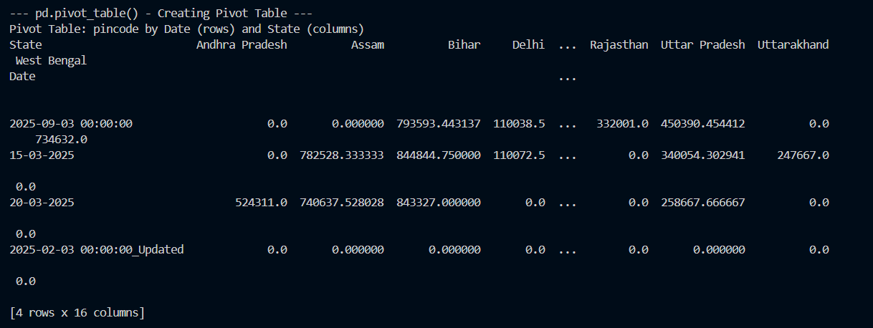

5. Grouping and Aggregation
- Grouped by Date, State, and multiple columns
- Calculated mean, sum, count
- Created pivot tables
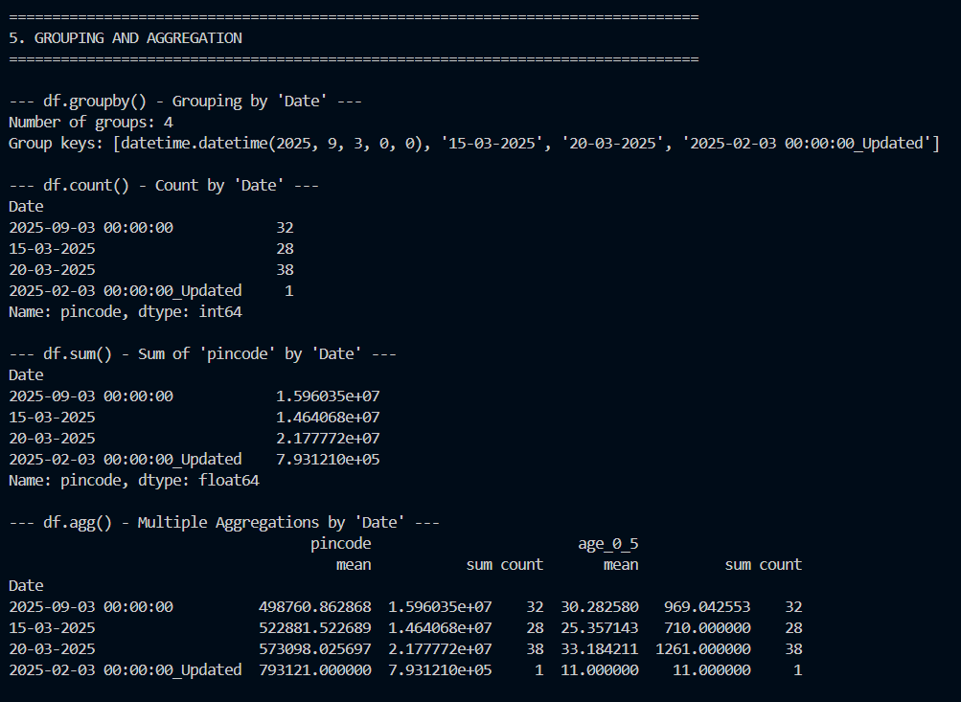

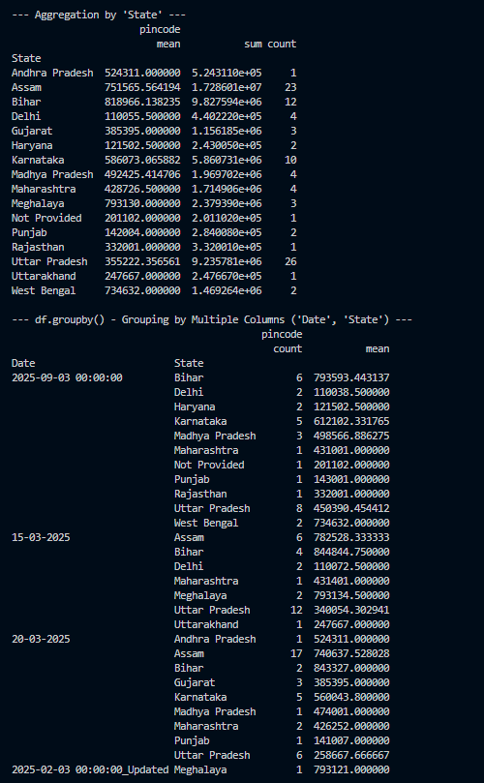
Conclusion
In this experiment, a comprehensive set of data wrangling operations was successfully demonstrated on the Aadhar Enrollment dataset using the Pandas library. The dataset of 99 records and 7 columns was inspected, cleaned of missing values through mean imputation and placeholder filling, and deduplicated. Derived columns were engineered using custom functions, and the data was sorted, pivoted, and aggregated using groupby() to extract meaningful summaries. File format conversion between Excel and CSV was also demonstrated. These preprocessing steps are essential in any real-world data science pipeline to ensure data quality and readiness for downstream analysis or modeling.

